Dalton Murray

Systems Analysis and Design

INT 6123 – Systems Analysis and Design

Dr. Andrew Makar

November 12, 2023

**IA #10 Spring Breaks R Us**

**Question 1 - The SBRU information system includes four major subsystems: Resort relations, Student booking, Accounting and finance, and Social networking. Although you have only worked with the domain model class diagram for the Social networking subsystem, list as many of the domain classes that would probably be involved in each of the subsystems. Note which classes are used by more than one subsystem.**

Resort Relations:

* Resort – Used by more than one subsystem
* Facility – Used by more than one subsystem
* Activity – Used by more than one subsystem
* Traveler/Account – Used by more than one subsystem
* Reservation – Used by more than one subsystem
* Invitee – Used by more than one subsystem
* Accommodation – Used by more than one subsystem
* Interest – Used by more than one subsystem
* Post – Used by more than one subsystem
* Post Comment – Used by more than one subsystem

Student booking:

* Resort – Used by more than one subsystem
* Facility – Used by more than one subsystem
* Activity – Used by more than one subsystem
* Traveler/Account – Used by more than one subsystem
* Reservation – Used by more than one subsystem
* Invitee – Used by more than one subsystem
* Accommodation – Used by more than one subsystem
* Payment – Used by more than one subsystem

Accounting and Finance:

* Resort – Used by more than one subsystem
* Traveler/Account – Used by more than one subsystem
* Reservation – Used by more than one subsystem
* Invitee – Used by more than one subsystem
* Accommodation – Used by more than one subsystem
* Payment – Used by more than one subsystem

Social networking:

* Resort – Used by more than one subsystem
* Facility – Used by more than one subsystem
* Activity – Used by more than one subsystem
* Traveler/Account – Used by more than one subsystem
* Post – Used by more than one subsystem
* Post Comment – Used by more than one subsystem
* Networked Connection

**Question 2 - Based on the overlapping classes, what domain classes seem to be part of the core functionality for SBRU? Draw a domain model class diagram that shows these classes and their associations.**

A majority of the domain classes have at least some overlap with one another as multiple subsystems will use most of the domain classes at least in one instance or another. The domain classes that seem to be a part of the core functionality for SBRU which has the most overlap are: Resort, Facility, Activity, Traveler/Account, Reservation, Invitee, Accommodation, however, the ones that are also used with other subsystems but are used less than these core ones are: Post, Post Comment, Payment and the subsystem with the least amount of overlap is: Networked Connection which is only used by the Social networking subsystem while all others are used by at least two subsystems.

I also have determined that all of these domain classes are required for the functionality of the entire system, without one of these classes their respective subsystem will not work properly.

A full, updated domain model class diagram for this can be seen below (also attached as PDF):

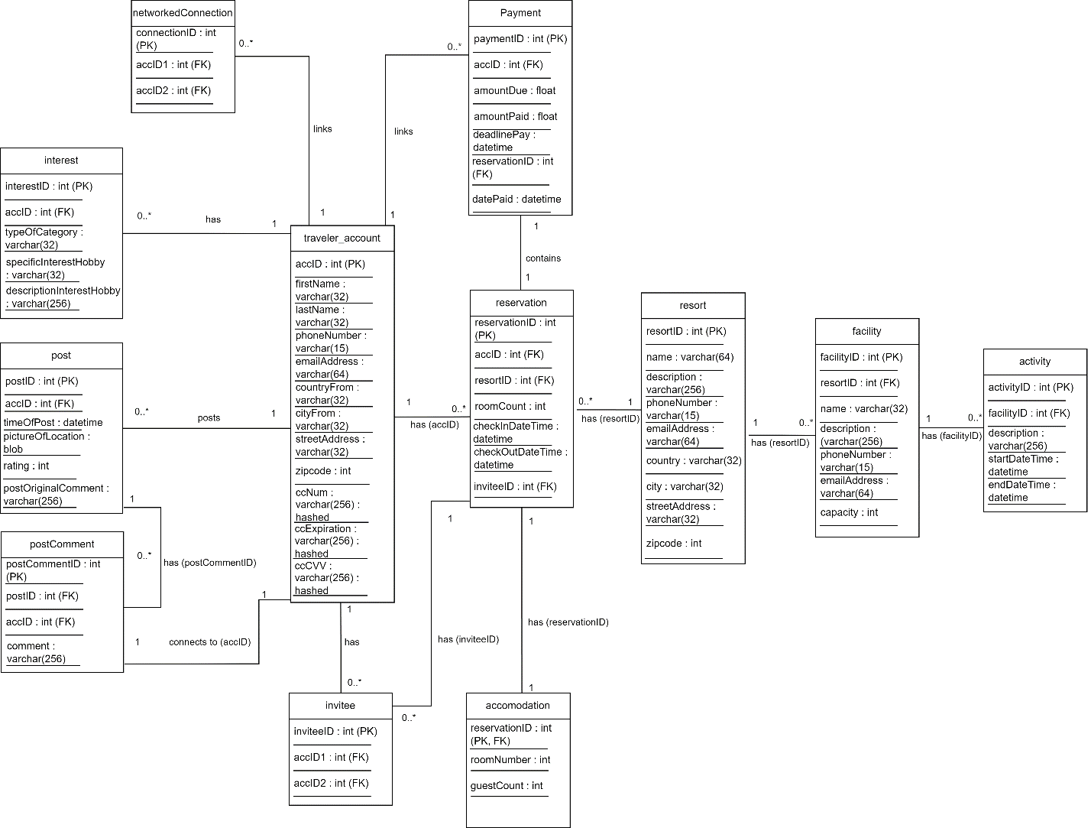

**Question 3 - Suppose you plan to implement the basic use cases that create and maintain the classes that are part of the core functionality you just modeled. Describe what domain classes you would focus on in each iteration if you assumed that you would need two iterations for the initial core functionality and two additional iterations to complete each of the subsystems.**

Due to the fact that each of the domain classes listed I believe to be required for each of the subsystems to properly work I will list them all in the order which I believe to be most important and how I would handle them for each iteration. I will also list the basic use cases for each of the domain classes/what they do in simplified terms.

(Domain Class

> Use cases)

Iteration 1 (Core functionality):

* Traveler/Account
  + Creating an account
  + Verifying payment information
* Reservation
  + View available bookings
  + View available rooms
  + Make a reservation
* Resort
  + View available resorts
  + View resort details
* Accommodation
  + Guest lookup
  + Room availability for future reservations
* Payment
  + Send payments
  + Notifications and reminders

Iteration 2 (Core functionality):

* Facility
  + View facilities
* Activity
  + View available activities
  + Go to activities
  + Search/filtering resorts

Iteration 3 (Subsystems 1):

* Invitee
  + Invite another person to the social network group
  + Invite another person to the room (not required for them to stay in the room as a guest)
* Networked connection
  + Connect with a random person
  + Filter people
  + Communicate with person (text, call, video)
* Interest
  + Filter resorts and locations by interests
  + Filter social network by interests

Iteration 4 (Subsystems 2):

* Post
  + Post posts onto locations with images and descriptions
* Post Comment
  + Post comments onto other posts

**Question 4 - How might you use incremental development to get some core functionality or some subsystems deployed and put into use before the project is completed?**

There are a large number of ways that people develop systems, and in a system such as this I believe agile would allow for the best approach. For an entire system such as SBRU if I were to start from the ground-up I would use the previous list of iterations that I created. This allows myself and the other developers to get the most core systems up first so that people can create accounts, and resorts can contact us to get their resorts added while working on all of the other systems. This will also allow payments to be made and people to stay at resorts at the earliest time possible. After this, we can then focus on refining the system and polishing it as we add more domain classes to the entire system such as the facilities, activities, the entire networking subsystem, and the entire social media subsystem. The point of doing it this way is that the facilities and activities listed are less important than making sure that the person can actually stay at the resort and only allows for more refining when searching for a resort which they are capable of doing without the SBRU system to do it as it is more of a convenience factor. The entirety of the social networking system and social media system also do not play a major role in actually being able to stay at the resort and are only benefits of using SBRU to connect with people and explore new places, which can also be done outside of SBRU’s systems.

While going through the previously listed iterations, I also believe it is important to note that with the approach we are taking that we occasionally go back to the previous iterations and refine and polish them further. We also need to make sure that we are always considering, with each iteration feedback from the guests and from the resorts to make sure our systems are how they want it because without them the company would not exist at all. As the requirement for the previous question was only 4 iterations I believe it would be more appropriate in the real world to break it into tons of more tiny iterations as we would constantly be going back and forth updating each of the subsystems to ensure that the guests are getting out of SBRU what they want, allowing us to build up the systems in time as we get the systems necessary for guests to stay at a resort working while working on the other less important subsystems at the same time. This would mean that starting from nothing we get the systems required for guests to stay up and online, then we work on some of the less important subsystems while still working on the primary/core systems, and we continue this until everything is in a spot where we like it, while doing this we also take feedback from the guests and update the systems how they think it should be.

**References**

Satzinger, J. W., Jackson, R. B., & Burd, S. D. (2016). Systems analysis and design in a Changing World (7e ed.). Cengage Learning.

I have neither given nor received unauthorized aid in completing this work, nor have I presented someone else's work as my own.

*Dalton Murray*